
Chapter 5: The Age of Exploration

Essential Question: What factors might motivate a society to venture into unknown regions beyond its borders?

The Desire to Explore
What elements of the worldview of Renaissance Europeans lead to exploration and expansionism?
Cartographer
Exploring to Expand ______________
Renaissance Europeans spent huge amounts of money on luxury goods and spices from the East.
Issues:

Solution:
Exploring to Expand the _____________________
The trading economy of Europe depended on the exchange of goods and resources for money.
Issues:

Solution:
Exploring to Expand _________________
Religion was very important aspect of people’s worldview during the Renaissance. Spreading Christianity became very important during the Age of Exploration.
Why?
- Renaissance explorers and the monarchs who sponsored their voyages believed:

The Means to Explore
How did the exchange of knowledge and technology make European exploration possible?
Navigation
Expanding the ___________________
Despite their openness and curiosity, Europeans’ knowledge of the lands beyond Europe was very limited.
Sources of Information:
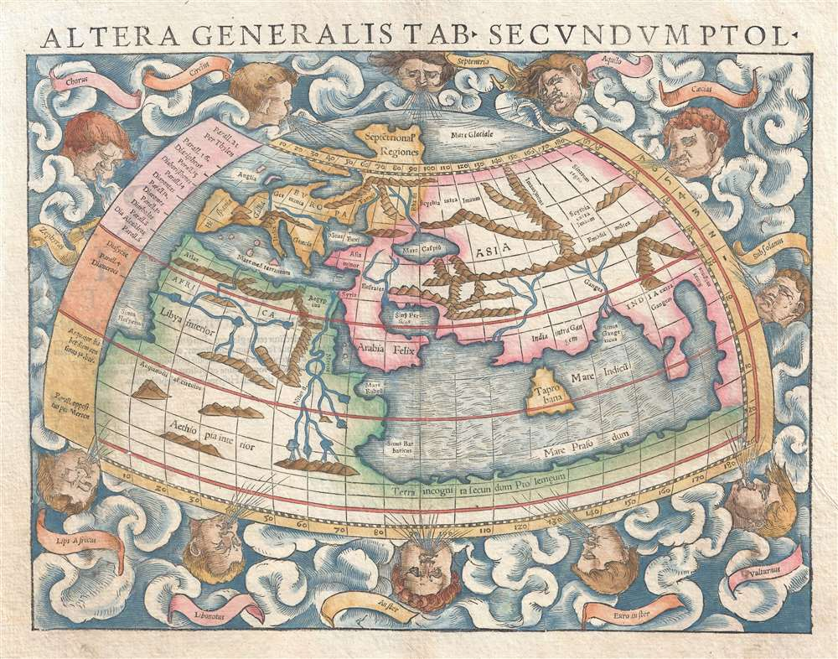
  - Issue:

  - Issue:

  - Issue:
Expanding the ___________________
For Renaissance voyages of exploration, ships that could travel across the ocean and navigational instruments that could keep these ships on course were essential.
Prince Henry of Portugal:
Established a centre where cartographers, mathematicians, astronomers, sailors, and navigators from all over Europe came to _____________________________________.
Here they improved/created:

Instrument | Use | Origin
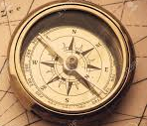
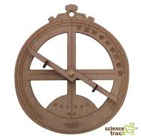
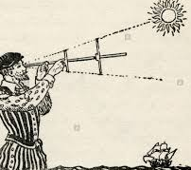
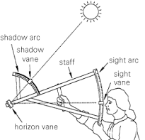
Ships also developed as Europeans encountered different elements such as sea vs ocean, wind strengths, rapids, materials available and encounters with other cultures.
European Expansion
How did the desire and means to explore foster an expansionist worldview?
Circumnavigate
Expansionism
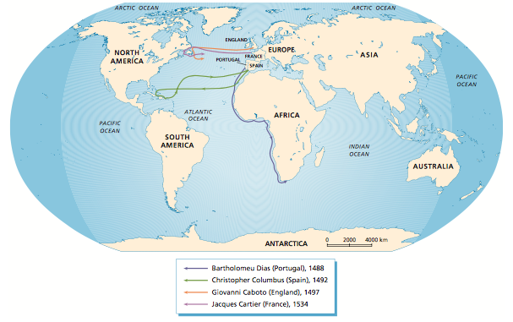
Portugal 1488
The first European country to become involved in organized exploration.
- Destination:

- Purpose:

Spain 1492
Christopher Columbus was convinced that a shorter route lay west across the Atlantic.
- Intended Destination:

- Actual Destination:

- Purpose:

He died bitter and poor after his fourth voyage in 1506, convinced still that he had reached Asia.
In 1520, Ferdinand Megellan sailed along the coast of South America and on into the Pacific Ocean. Eventually, he landed in the Philippines. After his death and his ship under new command, they returned to Spain loaded with spices.
- Spain was the first to:

England 1497 and France 1534
- Destination:

- Actual Destination:

- Purpose:

