Unit 2: Worldviews In Conflict

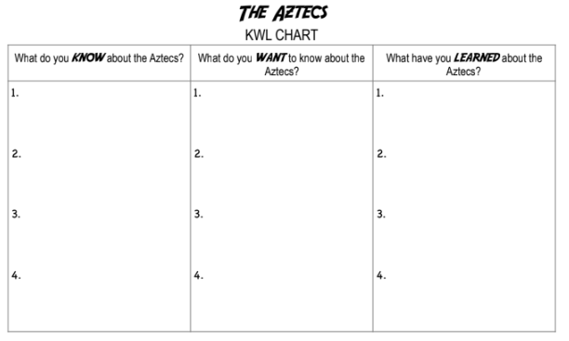
Explain their Worldview Elements pre- and post- contact

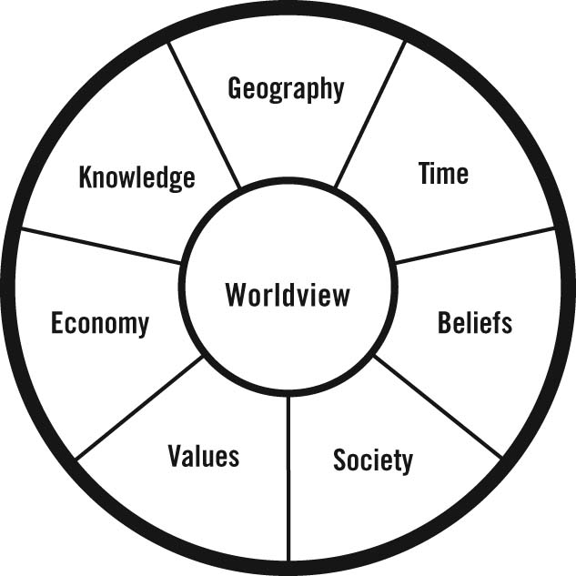

Chapter 7: The People of the Sun

Essential Question: In what ways do a group’s collective beliefs and experiences contribute to shaping a unique identity?

The Big Idea: The Aztec Empire reached its highest point of achievement and power about 500 years ago in the land we call Mexico. The People of the Sun, as the Aztecs called themselves, created one of the greatest civilizations the world has ever known.

The People of the Sun Legend – Page 151

Answer each of these questions about how the Aztecs came to settle in their home of Tenochtitlan.
- Where did the Aztecs live originally? ___________________________________
- Who was Huitzilopochtli? ____________________________________________
- Why did they move? ________________________________________________
- What direction did they travel? ________________________________________
- How would they know where to settle? __________________________________________________________________
- How long did they travel? ____________________________________________
- In what year did they arrive in the Valley of Mexico? _______________________
- What was the land life? ______________________________________________
- What was the climate like? ___________________________________________
- Why didn’t they settle on the fertile land? __________________________________________________________________
- Where did they end up settling? ________________________________________
- What did they call their home? _________________________________________
- How long did it take them to develop the swampy island into wonderful city? __________________________________________________________________
The Physical Landscape
How might a society’s worldview influence its __________________ to its physical _________________?
Aztec
Dike
Aqueduct
Chinampa
Artifacts
Primary sources
Secondary sources
Ometeotl
(oh-meh-THE-ohtl)
Geography
For the Aztecs, mountains were a _______________________________.
- They believed that through their height, they ______________________________________.
- The environment was very important to the Aztec people. The world consisted of two landscapes:

- The temples that Aztecs built to worship their gods were pyramids in the shape of ___________________.

The Aztecs believed their god ____________________________ had led them to the place where they lived.
- This was not an ideal location. It was a small, swampy island in a lake with salty water.
- _________________ was a powerful force in Aztec society and it gave the Aztecs the determination to survive there.
The Power of the Mountains
The mountains that surrounded Tenochtitlan gave the Aztecs a sense of _______________.

The mountains also _________________________.

Ingenuity

After a great flood swamped Tenochtitlan in 1500 they built a dam across the lake to control the water levels.

They also had to build an aqueduct to bring in fresh water from underground springs from outside the city.
An Island Home: Becoming a Society

The Aztecs also built ___________________ (bridges) that connected lakes to their mainland.

In the 200 years that they occupied Tenochtitlan they grew from a band of a ____________________into a society of __________________________________.
They became the most productive ______________________________ of their time. They grew enough food to feed
their entire society.
- Including:
Changing the Geography  Because of their determination to live in Tenochtitlan, the Aztecs  made alterations to their land to make it sustainable. |  | 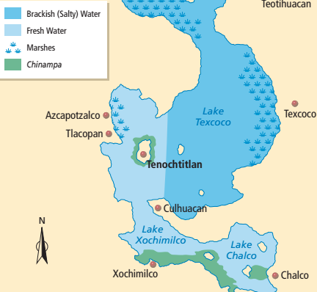
Present Day  _______________________ is built on the ruins of Tenochtitlan. After the Spanish conquering, they built their new city on the ruins in the lake bed and eventually had engineers drain the lake.  To provide water, the aquifer, ____________________________________, is being drained.  Since it is draining faster than it is being replenished, the city is sinking.  Estimates say it has sunk around 9 meters in the last 100 years! |  |  |  | 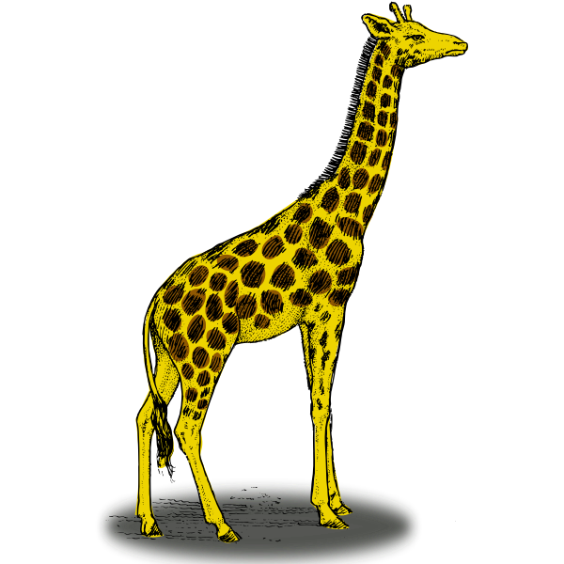  ~ 9 meters
Identifying and Using Sources

Primary sources are items that have survived from the past. Such as:

Secondary sources are accounts of the past written sometime AFTER the event/person. Such as:

Assignment: Write P for primary source and S for secondary source.

_____ a tool found at an excavation site
_____ a magazine article written about Aztec beliefs
_____ a journal entry written by an explorer
_____ a painting of Christopher Columbus’s first encounter with the Taino done by one of his crew
_____ a textbook about the Renaissance
_____ a tiny statue uncovered at an excavation site
_____ the remains of an Aztec temple
_____ a model of a chinampa

The Sacred Landscape
How did ______________________________ affect the worldview of the Aztecs?
Codices/codex
Solar calendar
Sacred calendar
Aztec Gods
The Aztecs believed that the Gods _______________________________________________________.
They looked to the God for __________________ on how to live. Although the Aztecs had _____________ Gods, they believed that ________________________________________.
God’s Name | Information | Image
Huitzilopochtli
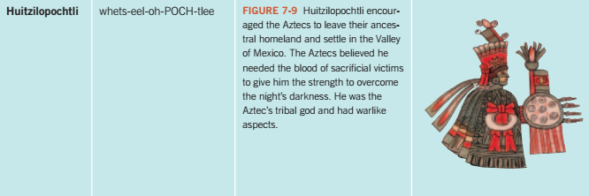
Tezcatlipoca
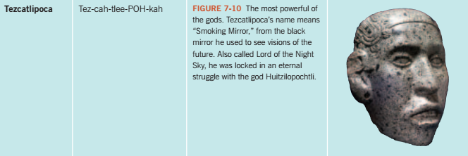
Quetzalcoaltl
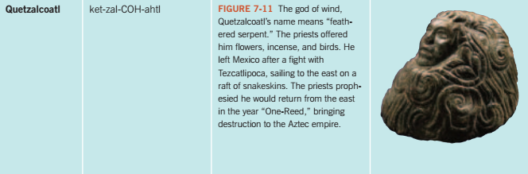
Tlaloc
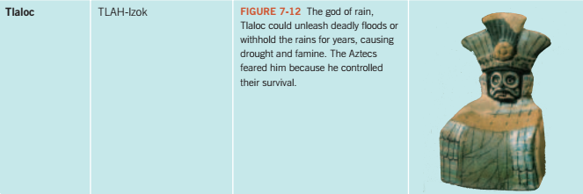

The Aztecs  The Aztecs kept codices in which they recorded information of their society. Codices are important ___________________________ for our understanding of the Aztecs’ beliefs.  The Spanish ________________________ almost all the Aztec codices when the conquered the Aztecs.  Later codices were created by Aztec codex-makers under Spanish supervision. |  |  | 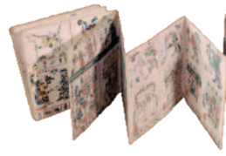
Measuring Time: Aztec Calendars  The Aztecs, Mayan, and other Central American societies developed the most accurate and complicated calendars in the ancient world. They were based on extremely accurate:  The Aztec calendar emphasized the close connection between __________ and __________________________, between the sacred and physical landscapes. |  |  | 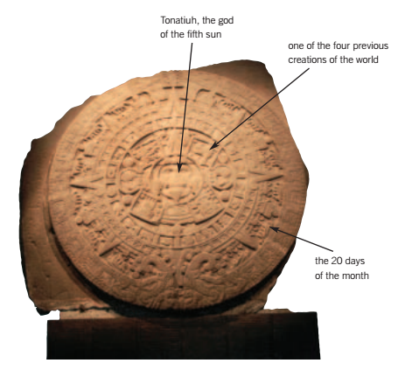
Aztec Calendar
The Aztecs actually had two calendars:

The sacred calendar was ________________ long. It took the sacred calendar exactly _____________ to “catch up” with the solar calendar.
Their great stone calendar, which was dedicated to Huitzilopochtli, showed how the world began and how it will end. The Aztecs believed there were four eras before the present one, and they had been destroyed by:

According to legend _________________________ will destroy the next one.
Human Sacrifice

Of all the aspects of the Aztec worldview, human sacrifice may be the hardest to understand. The Aztecs believed it was necessary to give the gods human blood.
Killing a human being for the gods has deep ____________________ significance. They believed:

War was very important for the Aztecs because it gave them new victims to sacrifice.
An important religious event called the “________________” ceremony took place every 52 years.
The people would fast and let their fires burn out. They waited on rooftops to see the sacred flame lit near Tenochtitlan, then a courier would carry this flame from house to house.
Tenochtitlan: The Centre of the World
The following sentences tell about Tenochtitlan. Fill in the blank. Page 163.

  - The Aztec believed that the Earth was a round, flat disc divided into four _______________.
  - Where the four sections met was Tenochtitlan, the _________________ city of the Aztecs.
  - Tenochtitlan was divided into four section, which ____________________ the four directions.
  - In the middle of the city was a large _______________________, which contained a large number of temples, including the Great Temple.
  - The Aztecs believed that the gods lived in the ______________________ and other places
  - The Aztecs thought mountains were sacred places and _________________ sometimes built temples on mountaintops.
  - As urban-dwelling people, the Aztecs needed to create _____________ places inside their cities.
  - Tenochtitlan had _______________________ of temples.
  - The most magnificent temple was the Great Temple, which was the physical and ____________________ centre of the universe.
Expanding the Empire
How did the Aztec worldview influence the way people __________________ with other cultures?
Didactic
Compulsory
Tribute
Expanding the Empire
As the Aztecs were on their journey to Tenochtitlan, they encountered other cultures. Along the way they were involved in conflicts. As a result, they became:

Expanding through Trade

This worldview influenced their behaviour and relations with peoples around them once settled in Tenochtitlan.

The Aztecs took great pride in these two aspects of their characters:

The Aztecs had to travel far distances to acquire the goods they wanted. Aztec merchants often set off with hundreds of slaves to carry the goods they purchased on trading expeditions. They were gone for months at a time.

If the Aztecs were such good farmers, why were they not self-sufficient?

The merchants also acted as ___________ for the Aztec army, drawing maps to show which cities were:

They were then given to Aztec leaders to expand their empire.

Expanding through War  Once they had made Tenochtitlan a powerful and successful city they were determined to create an empire. This is because they believed that Huitzilopochtli had said,  By the time the Spanish arrived in 1519, the Aztecs controlled an empire larger than any in North America.  They did this because they believed their group – or society – was more important than the individuals within it. |  |  |  | 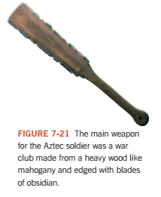
War Society

As soon as an Aztec boy was born, his parents placed a _____________________________ in his hands to symbolize:

Military service was compulsory among the Aztecs. The worst insult among the Aztecs was to call someone a coward; a lack of courage in any soldier weakened the army, which then threatened the state.

Once the Aztecs conquered a neighboring state, they would collect _______________ (valuable gifts and taxes from the group they conquered).

The Aztecs kept careful record of the tributes they collected. This included:

Cocoa beans were very important to them. The Aztecs made a drink from cocoa beans and chili peppers which they believed gave them ________________________________. Cocoa beans were also used as ____________________.

Chapter 7 Assignment: Research an Aztec God

Create a poster advertising your chosen God.
Include:
- Name of God with pronunciation
Grading /10

/2 marks for the picture
/1 mark for each point
/1 mark for overall impression

- What they were responsible for?
- What the name means?
- How the Aztecs honoured the God?
- Was this a great God or a minor God?
- 2 more interesting facts about the God.
- An image (if possible) of the God.

Aztec God Choices

HUITZILOPOCHTLI
TEZXATLIPOCA
QUETZALCOATLl
TLALOC
CENTEOTL
CHALCHIUHTLICUE
CHANTICO
CHICOMECOATL
CIHUACOATYL
COATLICUE
COYOLXAUHQUI
EHECATL
HUEHUETEOTL
IXTLILTON
ITZPZPALOTL

MACUILXOCHITL
METZTLI
MICTLAN
MICTLANTECIHUATL
MICTLANTECUHTLE
MIXCOATL
NANAUATZIN
OCOCALTZIN
OMACATL
OMETECUHLTI / OMECIHUATL
OMETOTCHTLI
OPOCHTLI
PATECATLl
PAYNAL
TECCIZTECATL
TEOYAOMQUI

TEPEYOLLOTL
TEPOZTECATL
TEZCATLIPOCA
TLAHUIZCALPANTECUHTLI
TLALOC
TLOQUE NAHUAQUE
TONACATECUHTLI
TONATIUH
TZITZIMIME
XILONEN
XIPE TOTEC
XIUHTECUHTLI
XOCHIPILLI
XOCHIQUETZAL
XOLOTL
YACATECUHTLI

