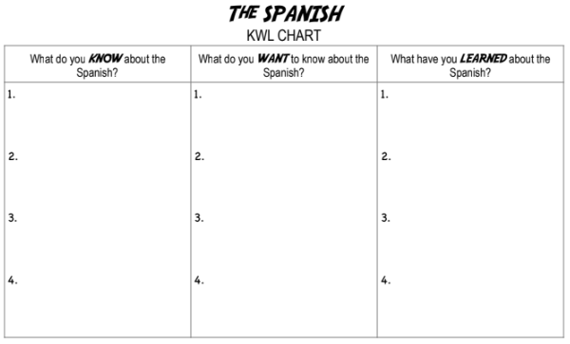

Explain the Spanish Worldview Elements pre-Aztec contact


Chapter 9: Spain Looks Westward

Essential Question: What elements of a society’s worldview might lead to a desire to create an empire?
The Big Idea: The worldview of Spain was influenced by four important factors: geography, God, gold, and glory. As a result, the Spanish monarchy supported the idea of creating an overseas empire.
Geography and Religion
How might the location of a country influence its religious experience?
Mosque
Hadith
Caliph
Caliphate
Martyr
Reconquista
Geography and Religion

The people of Spain have a saying: “La geographia manda, which means, “__________________________________”

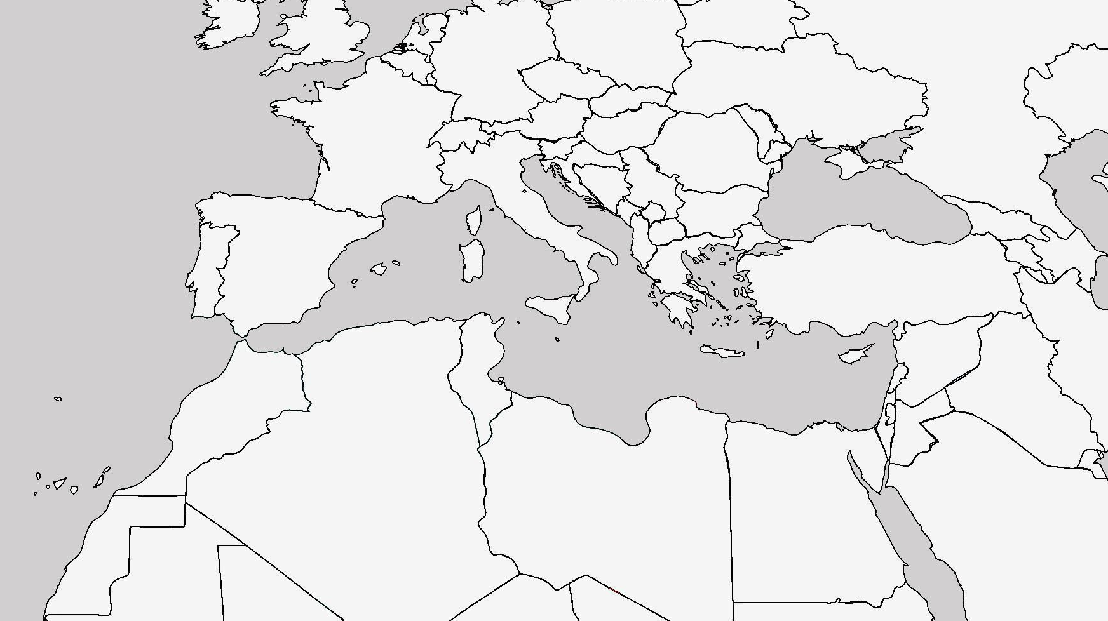

Muslim Spain

At the beginning of the Middle Ages (~475 AD), almost everyone in Spain, as the rest of Europe, was _____________.
Internal struggles and a series of weak rulers left the region vulnerable to attack.
Eventually, in 711 AD, a __________________ force landed in Spain. The Muslims conquered almost all of ______________________________.
To create a sense of _______________________, they began construction of a large, beautiful __________________ in Cordoba.

Life and Society

For the next five hundred years, after the Middle Ages, Spain was a part of a vast empire. The Arab Islamic world was part of the ___________________________________________________________________.
Muslim rulers and rich merchants supported the arts. Music, art, and architecture reflected ____________________.
For example:

They felt it may lead to people _______________ them (idolatry). Thus, their art reflected designs and written script.

Centres of Learning

This was over __________________ before the first university in Europe.
Scholars in the Islamic world knew much more about ________________________ than Europeans. They studied:

Religious Tolerance

Most historians agree that Muslim Spain was a society that was relatively _________________ of religious minorities.
Muslim Spain Falls

By the early 1000s the __________________ (areas of jurisdiction for Islamic rulers) began to decline. A series of ineffective rulers had led to civil unrest.

When the Muslims came to Spain, they had reduced the Christian-controlled area to a narrow strip along the north, but now they began to spread down south.

The ________________________ began as a result of this.

Creating a Christian Spain
In what ways did King Ferdinand and Queen Isabella impose their religious worldview on Spanish society?
Monotheism
Polytheism
Expulsion
Le Grand Derangement
Missionaries
Creating a Christian Spain
In 1469, King Ferdinand II of Aragon (Northeastern Spain) marries Isabella of Castile (Central Spain), two very devoted Catholics who wish to unite Spain. The only part of Spain that was in Muslim hands was Granada. It was captured in 1492 after ten years of fighting. Spain was now officially Christian territory.
The Spanish Inquisition
The Pope then announced that King Ferdinand and Queen Elizabeth would become _________________________ due to their devotion of their church.
The first step they took to unite Spain under one religion was to take over the Spanish Inquisition from the church.
The inquisition became a ___________________________ of courts where Church officials put __________________ on trial. After the Reconquista, Muslims and Jews were given a choice:

Saving Souls
The King and Queen began to believe it was their:

Gold and Glory
In what ways did the desire for gold and glory shape Spanish actions during the 1400s and 1500s?
Gold and Glory
In the Renaissance one of the key motivations for European explorers was the search for gold. They wanted to become wealthy themselves and the monarchs who supported their voyages needed gold to support their countries economies.
If a country had explorers finding gold and silver during these times it indicated that the country was rich.
They could then buy:

Wealth for Spain
The Christians had been fighting the Muslims for years and, by the time Granada surrendered in 1492, Spain’s reserves of Gold and Silver were almost gone.

Columbus’ Voyages

 | First Voyage  October 1492 | Second Voyage  September 1493
His Fleet
His Company
His Instructions

Gaining Personal Wealth
Traditionally, Spanish nobles only had two ways to support themselves:

Many nobles owned land and took ____________ from the peasants that farmed on their land.
There became a shortage of good farmland in Spain and nobles could no longer support themselves.

Taking a Risk for Glory
Not everyone was out to find gold. Some wanted to make a name for themselves, to earn respect in Spanish society.

The Poem of El Cid
Four qualities of his career:

These qualities became part of the ______________________________ which was suppose to govern the behaviour of the _________________________________.


