Key Term | Definition |  | Example
Machine
Machines were originally created to transport water; they are known as Roman Aqueducts. |  |  | 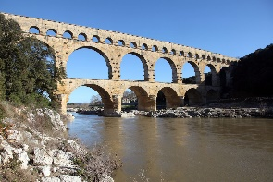
Mechanical Advantage
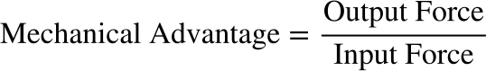
To pull a weed out of a garden, you can apply a force of 50 N to the shovel. The shovel applies a force of 600 N to the weed. What is the mechanical advantage of the shovel?

Input =
Output =

Imagine that you are lifting a patio stone using a pry bar as a lever. If the input force applied is measured as 25 N and the output force is measured as 250 N, what is the mechanical advantage?

I=
O=

Ideal Mechanical Advantage
Actual Mechanical Advantage
Mechanical Advantage <1
Trial and Error
Simple Machines | Simple machines are tools that make work easier. They have few or no moving parts and use energy to work. There are six simple machines, they are the;
Key Term | Definition |  | Example
Lever |  |  | 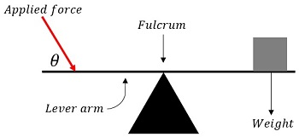
Advantage
Disadvantage
To find the Mechanical Advantage for the lever we use distance instead of force.

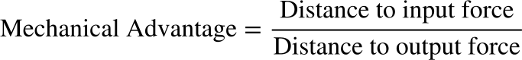
The distance from the fulcrum to the effort force applied is 120cm. The distance from the fulcrum to the load applied to the lever is 30cm. What is the mechanical advantage of the lever?

The distance from the fulcrum to the effort force applied is 40cm. The distance from the fulcrum to the load applied to the lever is 80cm. What is the mechanical advantage of the lever?

First Class Lever | Example:
Second Class Lever | Example:
Third Class Lever | Example:
What kind of lever?

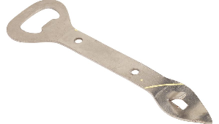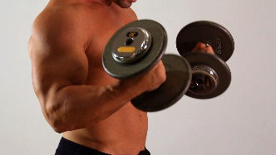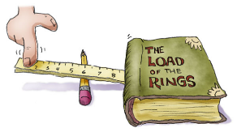

Inclined Plane |  |  | 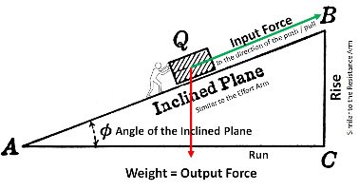
Advantage
Disadvantage
The Mechanical Advantage for inclined plane is measured by taking the length of the hypotenuse and dividing by the height of the inclined plane.
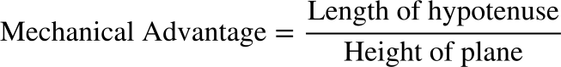
What is the mechanical advantage of an inclined plane that is 6 meters long and 3 meters high?

What is the mechanical advantage of an inclined plane that is 10 meters long and 7 meters high?

What is the mechanical advantage of an inclined plane that has a base of 4 metres and a height of 3 metres?

Wedge |  |  | 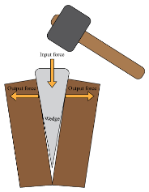
Advantage
Disadvantage
The ideal mechanical advantage of a wedge is determined by dividing the length of the wedge by its width.

If the head of an axe has a length of 30cm and a width of 10cm what is it’s mechanical advantage?

Wheel and Axle |  |  | 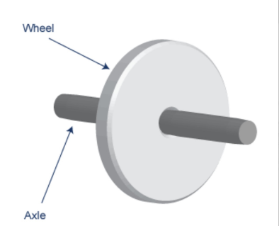
Advantage
Disadvantage
The mechanical advantage of the wheel and axle is the ratio of the radius of the wheel over the radius of the axle.

If a wheel's radius is 60cm and its axle is 30cm, what is the mechanical advantage of the wheel and axle?

If the wheel radius is 5m and axle radius is 2m. What is the mechanical advantage of the wheel and axle?

If the wheel area is 50m² and axle radius is 2m. What is the mechanical advantage of the wheel and axle?

Pulley
Advantage
Disadvantage
Fixed Pulley | Example: |  | 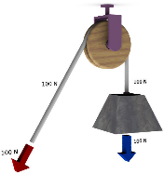
Moveable Pulley | Example: |  | 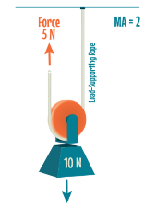
Compound Pulley | Example: |  | 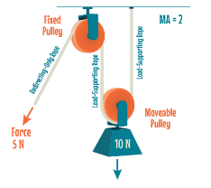
To calculate the mechanical advantage of a pulley you simply have to count the number of rope sections that support whatever object you are lifting.
For example: the fixed pulley has a mechanical advantage of 1.
What is the mechanical advantage?
Screw |  | 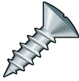
An Archimedes' screw, is a machine used for transferring water from a low-lying body of water into irrigation ditches. Water is pumped by turning a screw-shaped surface inside a pipe.
Advantage
Disadvantage
Divide the circumference of the screw by the pitc. Pitch is the vertical distance between two adjacent threads.
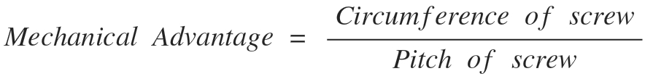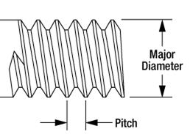
What is the mechanical advantage of a screw with a pitch of 5 inches, and a circumference of 10 inches?
What is the mechanical advantage of a screw with a pitch of ⅛, and a circumference of 0.79 inches?
If a screw has a diameter of 0.25 inches, and a pitch of 0.3 inches, what is the mechanical advantage of the screw?

System
Subsystem
Complex Machines
Linkages

Chain Drives and Drive Belts |  |  | 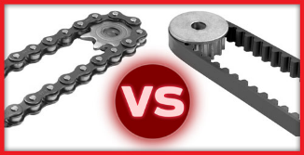
Drive Shaft

Gears

Driving Gear  vs.  Driven Gear |  |  | 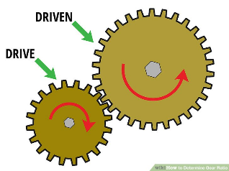
Multiplying Gear System

Reducing Gear System
The gear ratio of a gear train is found by dividing the number of teeth on the driven gear by the number of teeth on the driving gear. The lower the gear ratio the slower the output speed will be for that gear system.

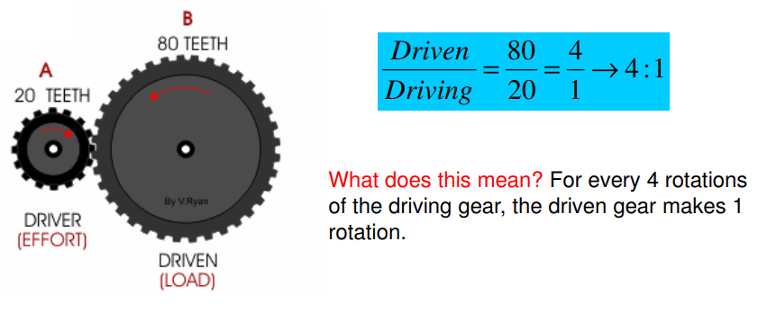
Newtons (N)
Speed Ratio
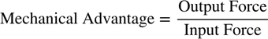
Calculate the Mechanical Advantage and the Speed Ratio
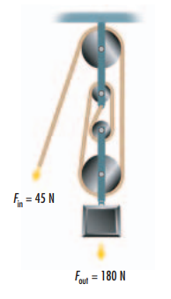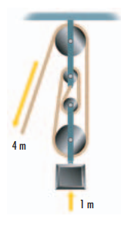
A pulley system lifts a load 5 m when two people pull the rope 10 m. What is the speed ratio?

Friction
Efficiency
Calculate the efficiency if a pulley has a speed ratio of 3 and a mechanical advantage of 2.

Calculate the mechanical advantage, speed ratio and efficiency of each.

Work
Work is measured in Joules or Newton Metres and is calculated as;

Work = Force x Distance
If a man pushes a concrete block 10 meters with a force of 20 N, how much work has he done?

How much work is done in pushing an object 7.0m across a floor with a force of 50 N and then pushing it back to its original position?

Calculating work can be tricky when considering simple machines. It is important in this case to examine the input force and distance, as well as the output force and distance.
The output force and distance will be used to calculate the work done by the simple machine.
An inclined plane is 6.25m long and 1.25m high. The force applied by a box on the inclined plane is 200N. If the box is moved up the inclined plane, what is the work done by the inclined plane?

Mr. Clobber has to move a dishwasher into a moving truck, the deck of which is 2.5m high. He decides to use a ramp, which is 7.5 m long. The weight of the dishwasher is 900 N, and he exerts a force of 350 N as he slowly pushes the dishwasher up the ramp into the truck. What is the work done by both the ramp and Mr. Clobber?

Efficiency of Work
An ideal machine would have 100% efficiency, which is not possible.

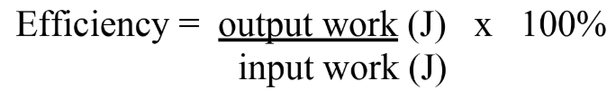
You cut the lawn with a hand lawn mower. You do 250,000 J of work to move the mower. If the work done by the mower in cutting the lawn is 200,000 J, what is the efficiency of the lawnmower?

To pull a nail out of a wood board a carpenter does 1000 J of work. The hammer he uses does 835 J of work. What is the efficiency of the hammer?

Pascal’s Law |  |  | 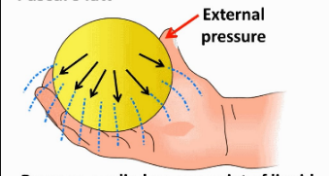
Pressure
Pressure is measured in Pascals or Newtons per metre squared.
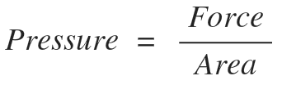
We use Pascal’s Law to find the proportion needed to work hydraulics. The force and area of both pistons are proportionate to each other.
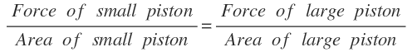
If the force applied to a small piston is 20N over an area of 4cm². How much force would be applied by a liquid in a proportionately large piston with an area of 100cm²?

In a hydraulic-brake system, a force of 25N can be applied to a surface area of 5cm². What force can then be exerted on each brake cylinder having an area of 100 cm²?

Section 3.0 Evaluation of Mechanical Devices
Criteria | Example:
Efficiency
Function
Design
Considering the Environment | What effect does the device have on the environment?  For example, spikes on a mountain bike may make the bike more effective in climbing slopes. However, this would tear up soil and plants more so than an ordinary bike.
Mechanical Systems Project

