Renaissance Unit Final Test Study Guide
**Remember: A solid understanding of these terms/topics will help you APPLY your knowledge to DEMONSTRATE your understanding. Deep and critical thinking will be necessary. There will be a written response question that will require you to demonstrate further than just surface knowledge.

Circumnavigate
Expansionism
Imperialism
Decolonization
Immunity
Renaissance
Indigenous
Protestant Reformation
Back-staff
Classical
Usury
Caravel
Scientific Method
Excommunicate
Heresy
Vernacular
Humanism
Republic
City-State
Hinterland
The Crusades
Silk Road
Black Death
Feudalism
Serfs
Monastery
Journeyman
Hierarchy
Allegiance

Catholic Counter-Reformation

- What is Worldview?

- What institution had the most power and then lost some of it when Humanism began to take hold?

- What is feudalism?

- What was the major factor that resulted in the disappearance of feudalism?

- What class were most of the people during the Middle Ages?

- Why did people eventually become upset with the Roman Catholic Church?

- What was the Silk Road and where did it run? What oceans did it connect?

- What happened as a result of the Crusades?

- What led to the emergence of powerful city-states? What were each main city-state known for?

- What are the classical civilizations and how did they impact the Renaissance?

- What did the Humanists believe in regards to the individual?

- What were the main scientific discoveries in the area of Astronomy, and who discovered what?

- What is the Scientific Method?

- How did the Church feel about people in the Renaissance learning new things and what kinds of things did they do to stop them from learning them?

- Who was Machiavelli and what did he believe?

- What were the main reasons that people from the Renaissance wanted to explore?

- What advances allowed them to explore and what kinds of things did they learn about as a result of these travels?

- What is an expansionist Worldview?

- What kind of attitude did the European countries have towards the newly discovered lands, how did they treat the people and what did they do with the things they found?

- What does Renaissance mean?

- What kinds of effects did the invention of the printing press have on the Renaissance?

- What is an imperialist worldview?

- Who were the main powers competing for territory during the Renaissance?

- What were the qualities of a Renaissance individual?

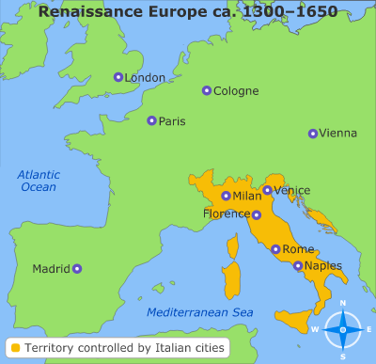

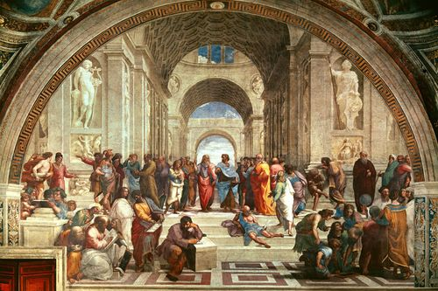
Renaissance
vs
Middle Ages


