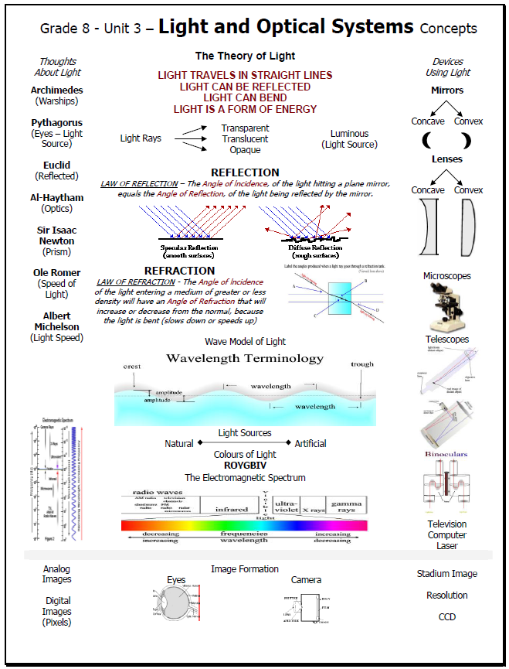

Section 1.0: Our knowledge about light and vision comes from explanations, inventions, and investigations.
Key Term | Definition | Example
Light
Energy
Luminous |  | 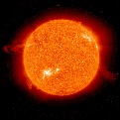
Non-luminous |  | 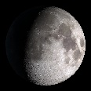
Vision and Challenges
Archimedes |  | 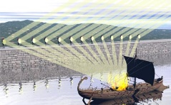
Pythagoras |  | 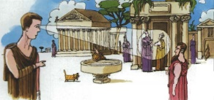
Timeline | 1st Idea:  2nd Idea:  3rd Idea:  4th Idea:  5th Idea:  6th Idea:  7th Idea:
Light Year

