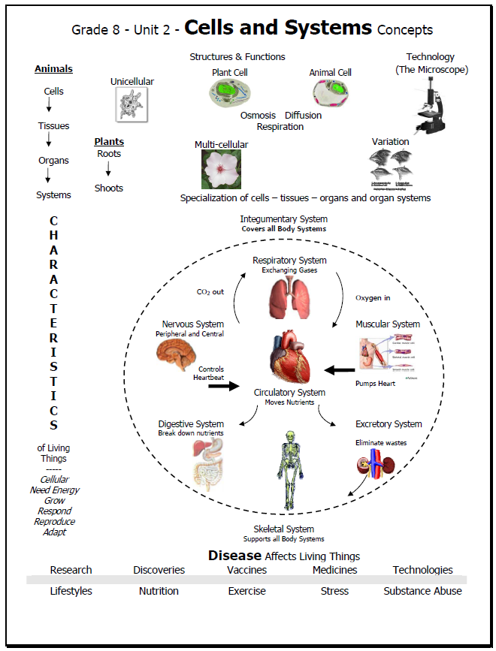

Section 1.0: Living things share certain characteristics and have structures to perform functions.
Key Term | Definition |  |  | Example
Microscope
Stereoscopic Microscope |  |  |  | 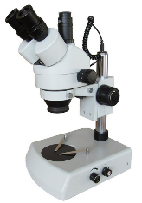
Transmission Electron Microscope |  |  |  | 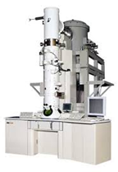
Scanning Electron Microscope |  |  |  | 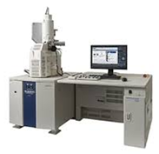
Compound Microscope |  | 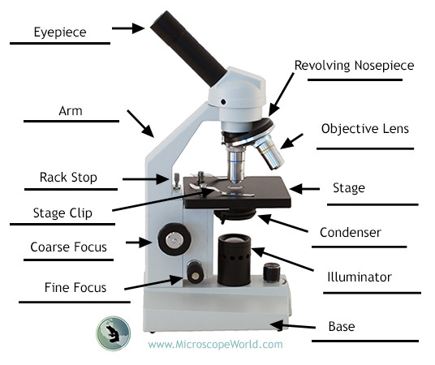
Scientific Drawings | 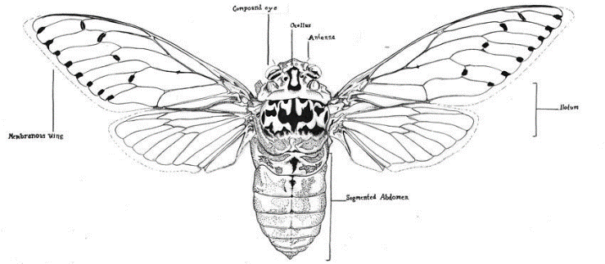
Scientific Drawing Rules

What is Incorrect? |  |  | 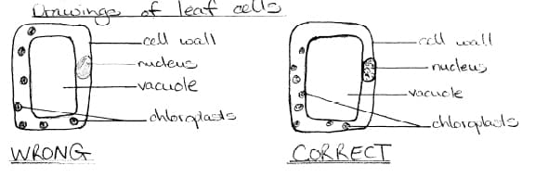
7 Characteristics of Living Things

Organism
Cells
Energy | Plants:  Animals:
Photosynthesis | 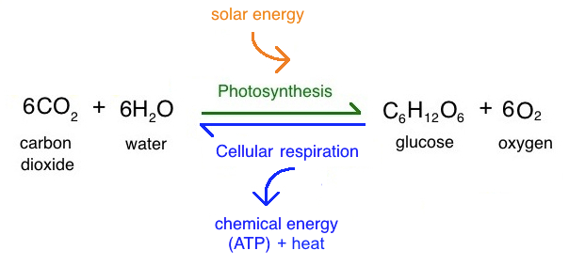
Metabolism
Growth and Development | 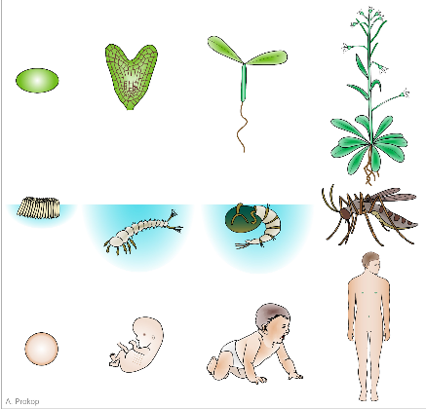
Growth
Repair
Development
Aging
Reproduction
Response to Environment
Stimulus
Response
Receptors
Fight or Flight
Homeostasis
Adaptation
Structural Adaptation
Behavioural Adaptation
Structural Adaptations Assignment

With a partner, choose an organism you are interested in and research their unique lifestyle and adaptations.

Requirements:
- Environment/Habitat of the organism
- Energy sources of the organism
- Behavioural adaptation
  - What is it?
  - How does it aid your organism in surviving?
  - Explain the organisms process in completing this behaviour
- 2 structural adaptations
  - What are they?
  - What is their function and how are they used by your organism?
  - How does this aid your organism in surviving/everyday life?
  - Labelled on your photo
- One “fun fact” about your organism
- At least one picture of your organism

Presentation:
You can present the following information in any format that you would like, as long as you include all of the above information. However, on the day of presentation you will be required to present your information in a ‘science fair-style’ format. This could be a poster, tri-fold chart or brochures. Remember, other students will be walking around to view your presentation and compare adaptations with the organism they have chosen.

Marking:
Environment | /1
Energy sources | /2
Behavioural adaptation | /3
Structural adaptations | /6
One Fun Fact | /1
One labelled picture | /2
Total | /15

Brainstorming/Research

