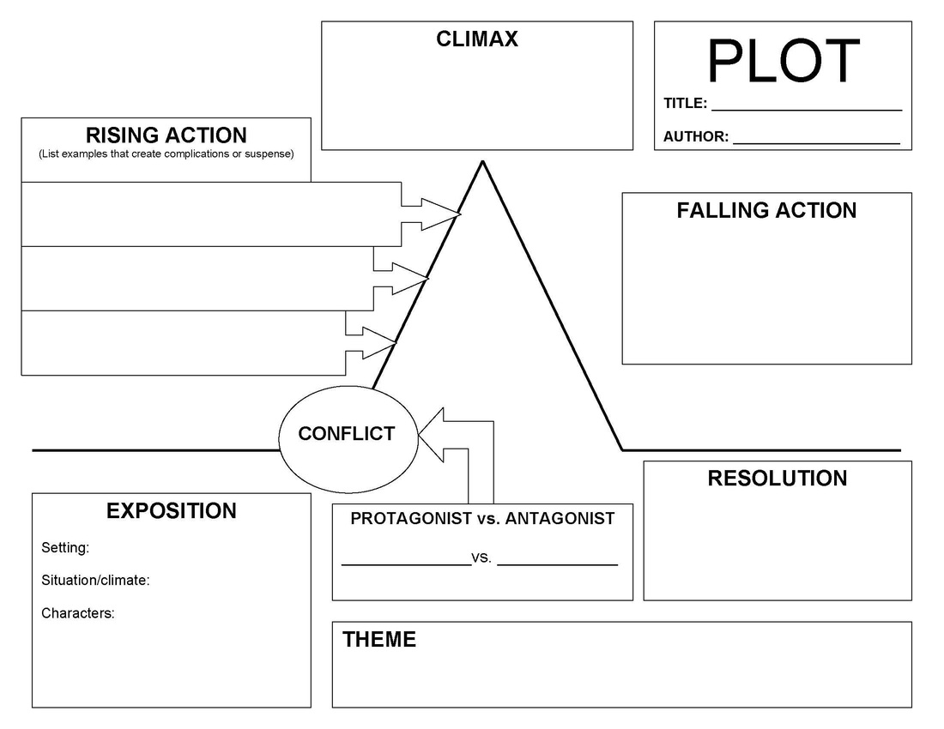
How did the story end? What was the result of the conflict?
The problems in the rising action get resolved.
The main moral or message of the story. What did the main character learn from the events of the story?

“The Sea Devil” by Arthur Gordon Response Questions

- Why does the man fish by night? How does this lead to the conflict with the ray?

- What dilemma does the man face before the climax? What enables him to get free of the sea devil?

- What has the man learned at the end of the story? How does the reader know this?

- Identify the two main types of conflict in this story and briefly explain.
(Man vs. Man, Man vs. Nature, Man vs. Society, Man vs. Self)

- Identify one example of foreshadowing (when the author gives clues and hints about what is to come in the story).

- Identify three examples of figurative language use.

- Highlight four areas in the story where the author made “flavourful” word choices to help create an image. (Places where he could have used a simple word like run, but instead uses torpedoed.)

CHARACTER ANALYSIS
Character’s Name:
Draw a picture of the character
Personality Traits

Resolution
Other attributes (Personal opinions, notable ideas/choices, family/relationships)
Conflict
Physical Appearance

