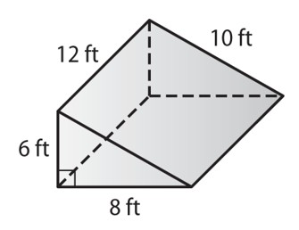
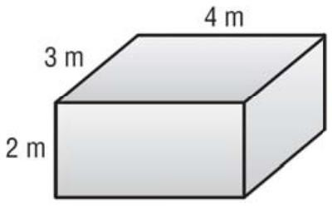
- 2.

Surface Area Surface Area

Volume Volume

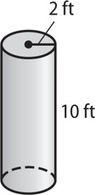
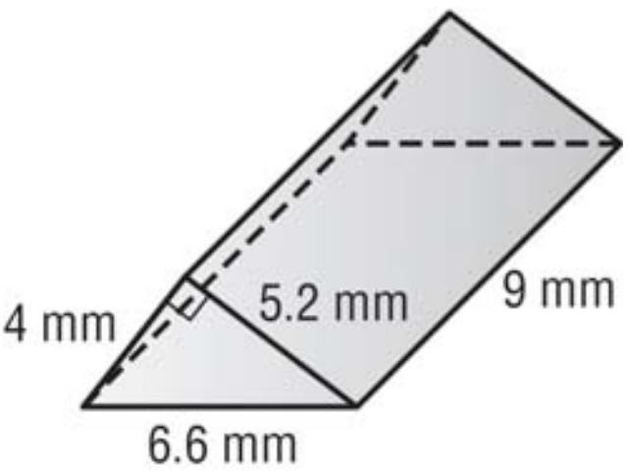
3. 4.

Surface Area Surface Area

Volume Volume

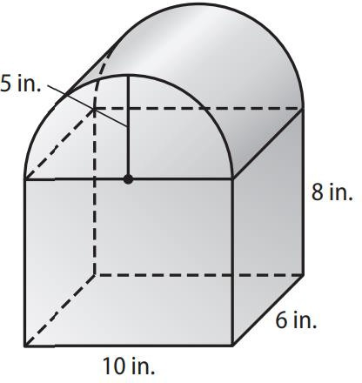
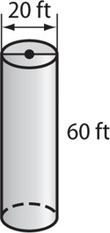
5. 6.

Surface Area Surface Area

Volume

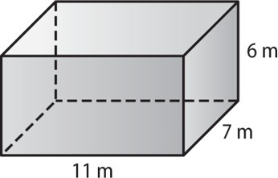
Determine the surface area of JUST the top and base.

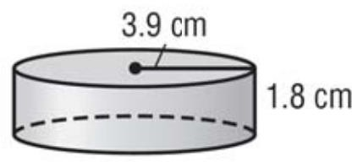
Determine the surface area of the cylinder without the top.

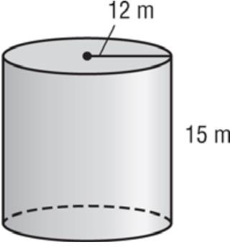
Determine the height.
V = 6785.84 m³

Determine the surface area of a cylindrical tank with a height of 12 m and a diameter of 10 m.

Determine the height of a cube with a surface area of 486 cm²

Three identical tennis balls with a diameter of 8cm are stacked three high in a cylindrical container.
- What is the volume of the container?

- Surface area?

Determine which cylinder holds more. Fill out the chart with your known information.
