Name:________________________ /20
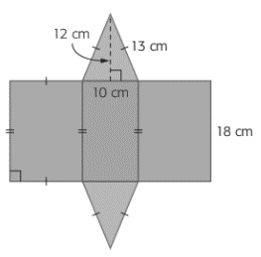
Triangular Prism Skill Check
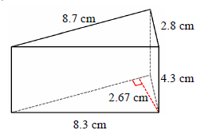

- Calculate the surface area. 3. Calculate the surface area.

- Calculate the volume. 4. Calculate the volume.

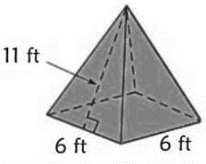
- John has enough paint to cover 175 square feet. He wants to paint this entire square pyramid, including the base. Does he have enough paint? How much more does he need, or how much does he have left over?

- The length of a triangular prism is 24 feet and the volume is 1,944 cubic feet. Find the height of the base triangle, if its base is 18 feet.

